**Lab 1**

**IntelliJ IDE**

**Getting Started**

The IntelliJ IDE is available to download from the following url: <https://www.jetbrains.com/idea/download/#section=windows>

Make sure to download the community edition which is free to use.

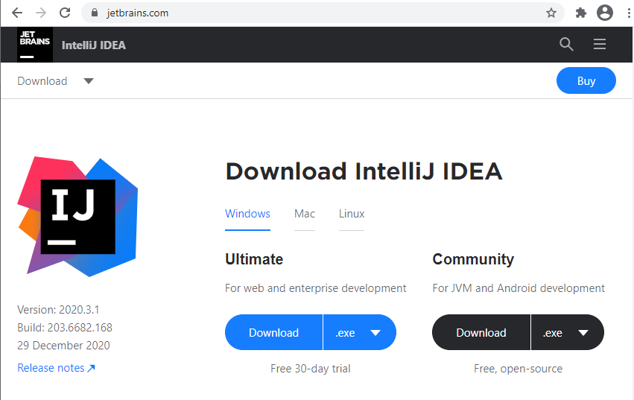

The following executable file should be available in your downloads folder:



Double click on this file to commence installation. You may see a security message asking for permission to install the application.

A welcome screen is then displayed as shown here so click **Next** to proceed.

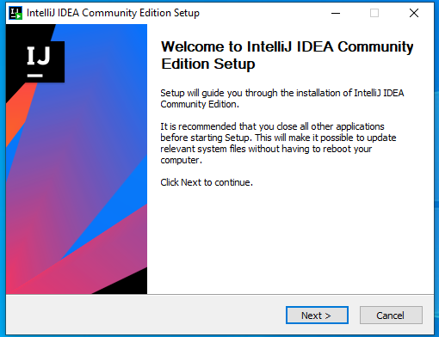

Next you are asked to select the installation location. When this is none, click **Next** to proceed.

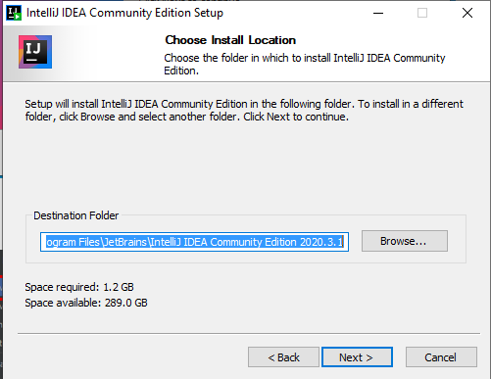

The following screen has installation options some of which are useful to select as shown below:

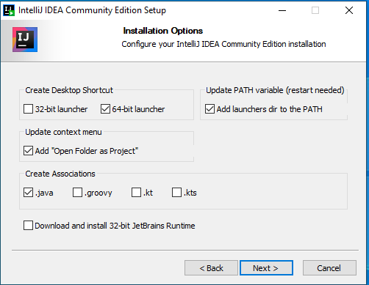

The following screen shows the default start menu folder which there is no need to change – just click **Install**.

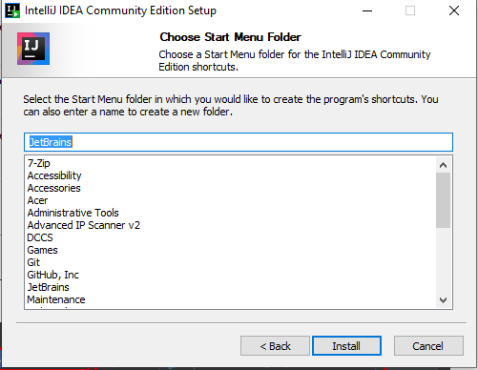

When installation is finished you will need to restart your computer either now or later as shown in the option below. Make sure you have all your files closed before you reboot.

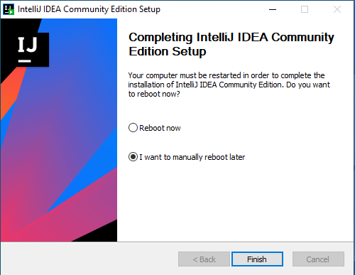

After rebooting your computer, you can launch IntelliJ by clicking on the desktop icon as shown below:



After launching IntelliJ for the first time you will be asked to accept the terms of the user agreement. Tick the checkbox and click **Continue**.

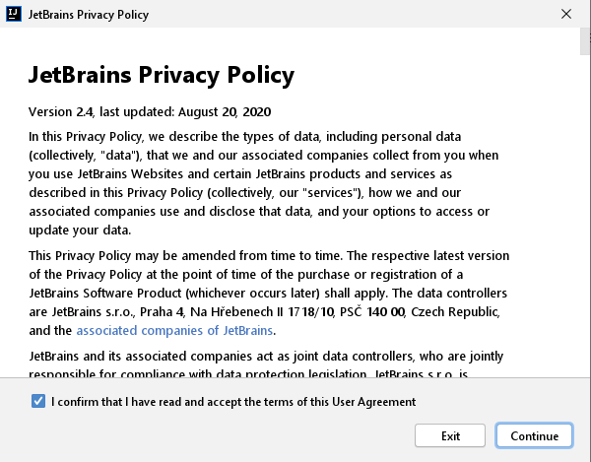

Next you will see the welcome screen where you can create a new project, click the **New Project** option shown below::

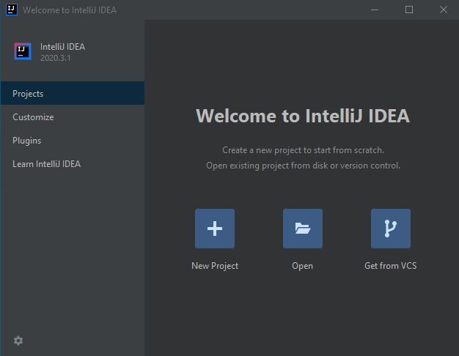

The New Project screen appears and now we need to select the jdk (Java development kit). If there is no jdk installed you will see an option to download it as shown below:

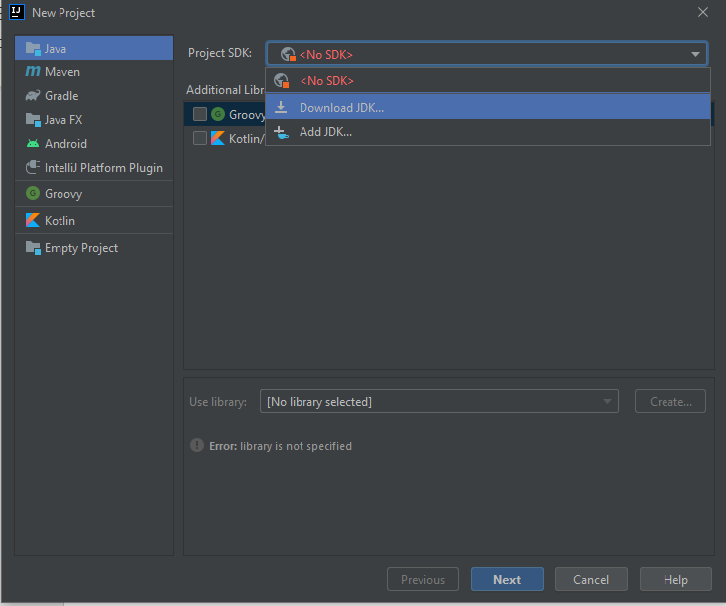

When you select the Download JDK option you will see a screen like the following showing the version, the vendor, and the location where the sdk will be downloaded to. Click **Download** to proceed.

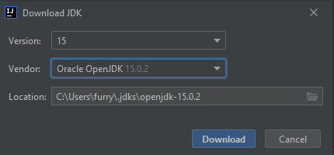

When the download has finished you will see the jdk version 15 is now selected as the project sdk. Click **Next** to proceed with creating a new project.

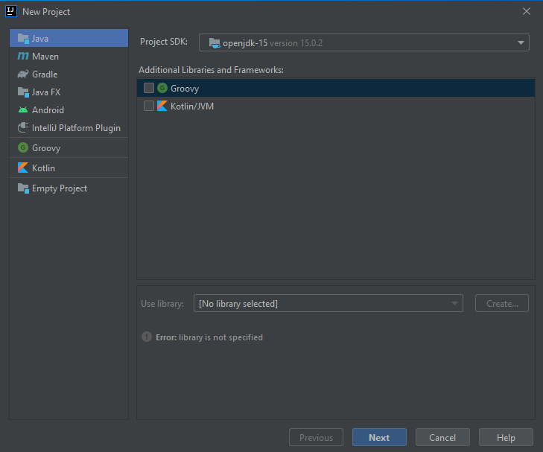

In the next screen that is displayed, tick the checkbox to create a project from a template and click **Next**.

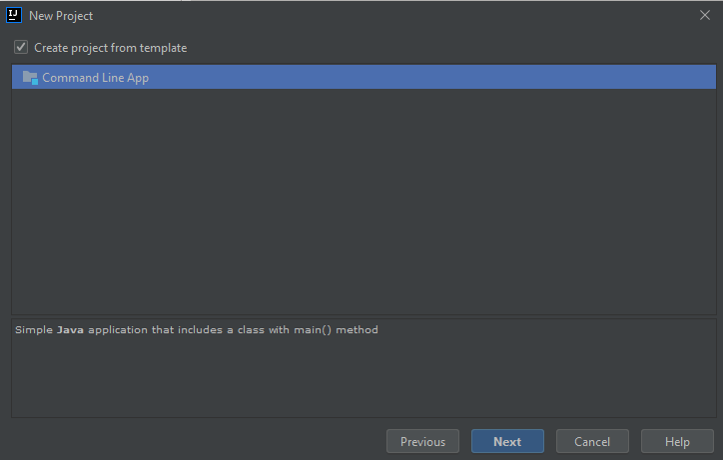

The next screen gives you to option to select the name of the project, the location for your project and the base package name. In the project location below there is a folder already created called WEEK1 but the TestProject folder does not exist yet. When you have these specified, click **Finish**.

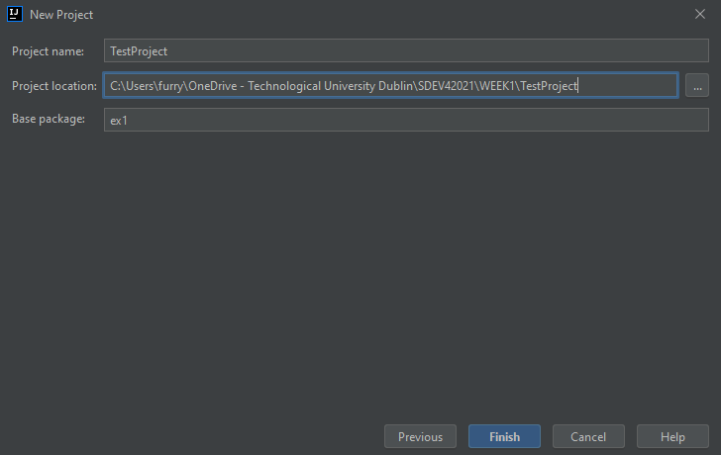

When you click **Finish** you will see the following screen telling you that the folder TestProject will be created. Click **Create**.

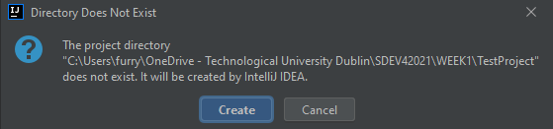

You should now see a screen similar to the following showing the project structure on the left-hand side and the Java class on the right hand side:

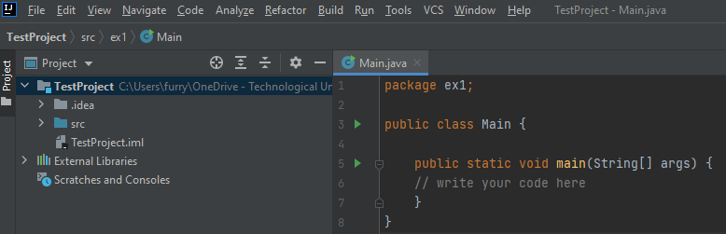

Type the following line of code into the location shown below:

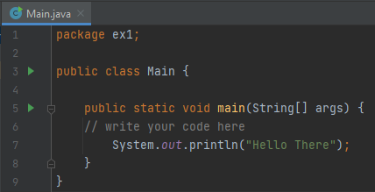

To run the program, click the green play button in the toolbar.



You should see the following output at the bottom of the screen.

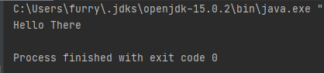

You are all set up now to write your Java programs!